How to reboot telemetry board without shutting off AC to ETG transmitters
- Log into your WEB GUI interface.
- Go to the “Wrench” icon on the top left of screen and select it. 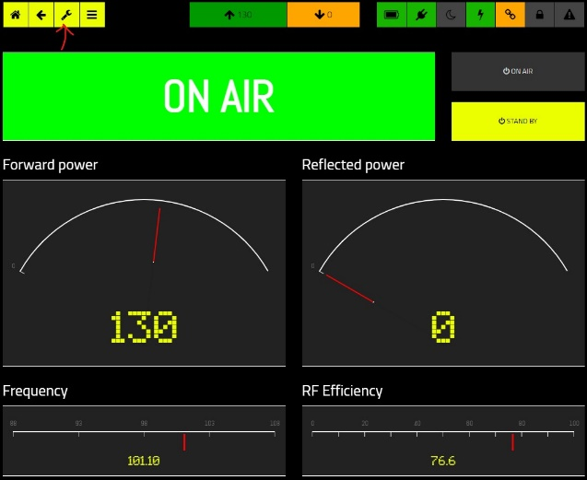
- Go to the “Module Configuration” icon and select it.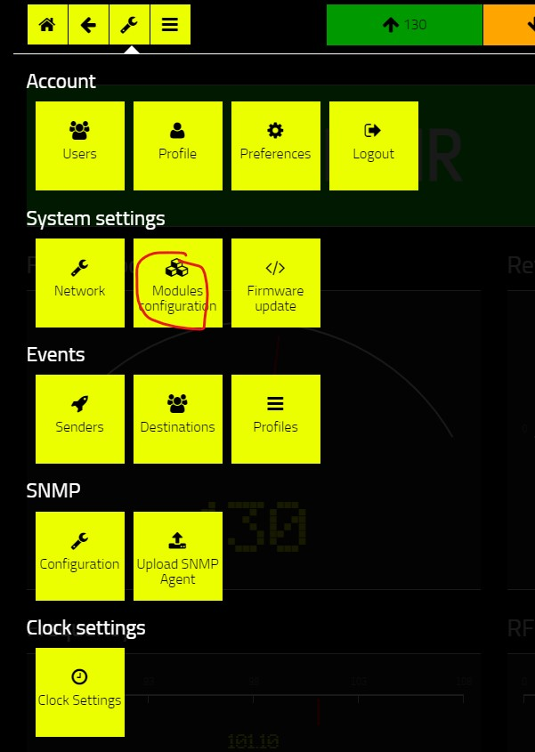
- Select the “Reboot” next to Reboot operating system. 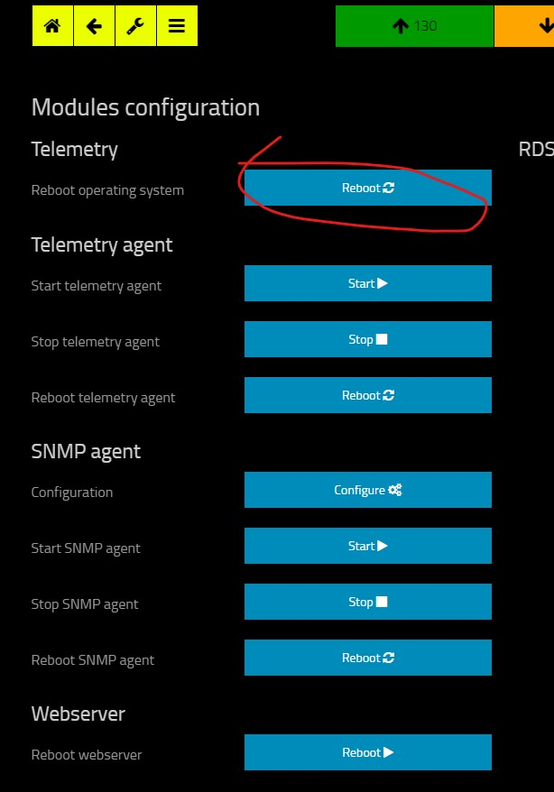
- This should reboot the telemetry card and should reconnect when finished.

