UPLOAD NEW AGENT

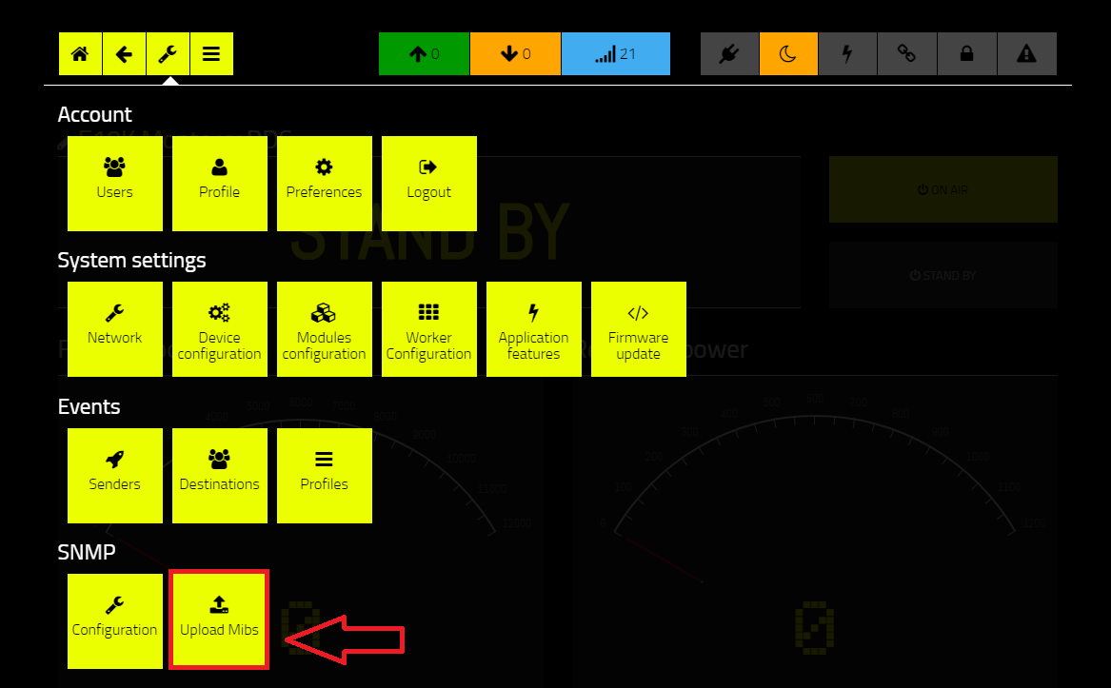
Click on the “upload Mibs” sub menu.

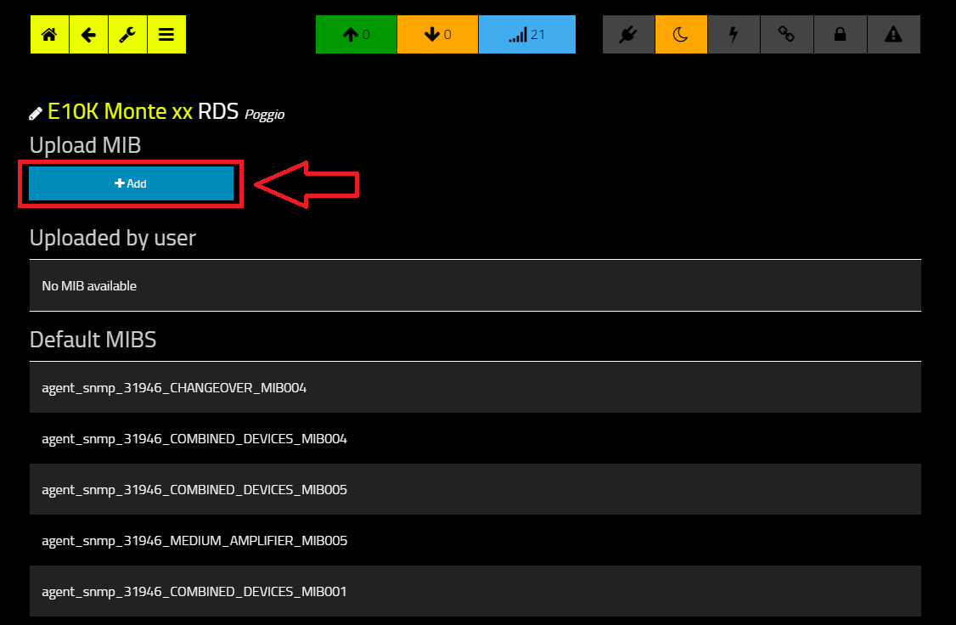
Click “+ Add” Button
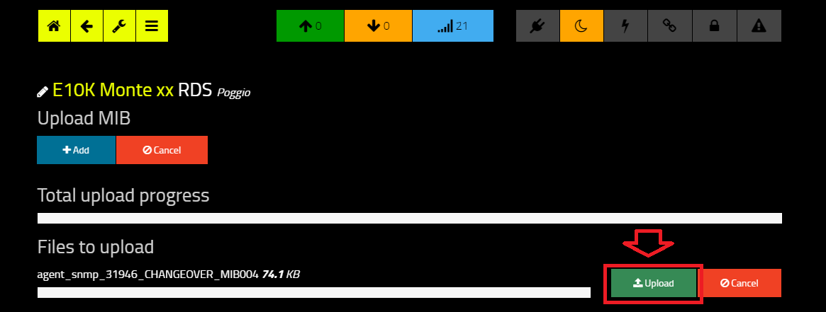
Select the agent File and click “Upload”

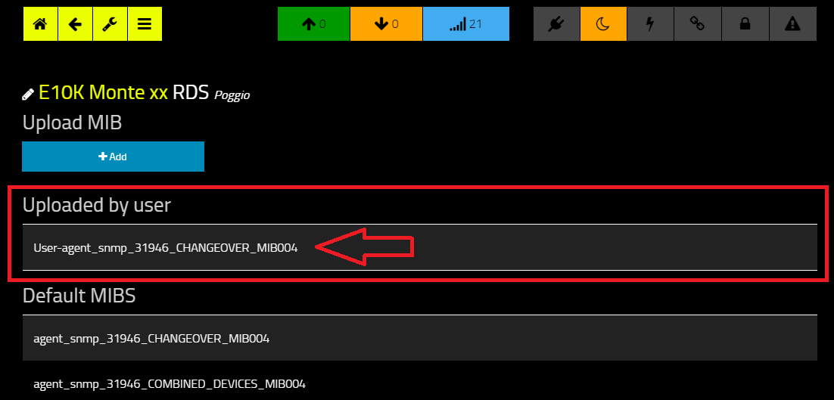
Here you’ll see the file you have uploaded. It has been renamed with “user-“ prefix to make it easier to be identified .

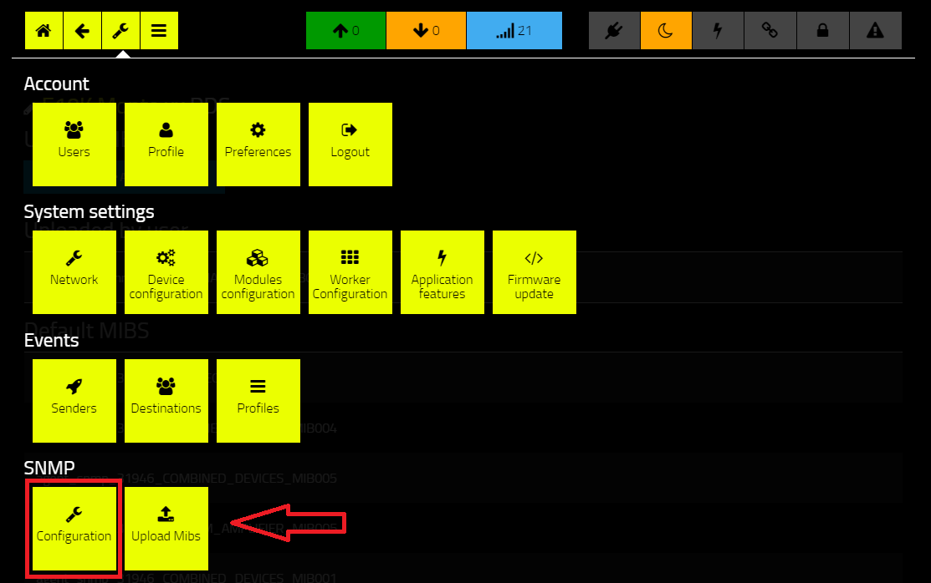
Click on the “Configuration” sub menu.
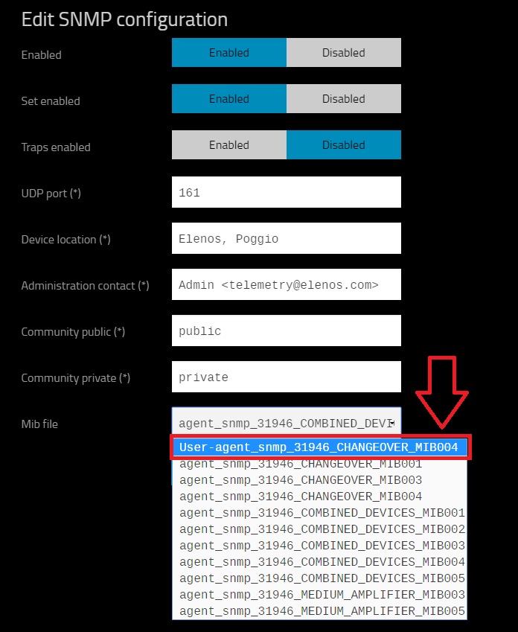
Select the agent file you have uploaded.
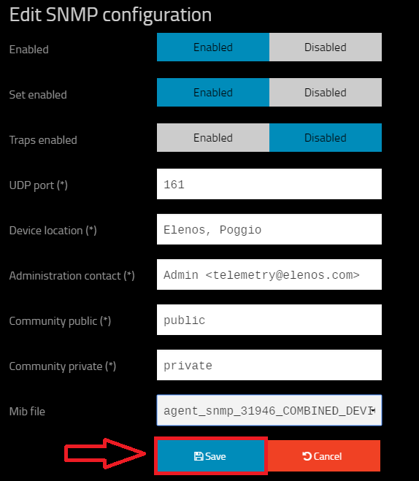
Click “Save”.

